Our Wedding Day

It’s about time, don't you think? After seven years, Joseph finally proposed! (I know he was worth the long wait) I'm so excited for our big day:

When?
Friday, July 10th, 2015

Ceremony

Coney Island Gospel Assembly
2828 Neptune Ave
Brooklyn, NY 11224

Reception

Rivieria Caterers
2780 Stillwell Ave
Brooklyn, NY 11224

We've invited more then 150 guests
to celebrate the beginning of forever;
but I promise you won't be lost as one of
my favorite people in the whole wide world.

Your Role...

I know weddings can become a lot of
work for Bridesmaids. Please know
that enjoying this process is one of my
top priorities. Just because I enjoy all
the little details does not mean you have to. Be you! (that's who I love.)

As My Bridesmaid your only job is to:

1. Enjoy hanging out w/me & lend a helping hand along the way.

2. Smile & make new friends at my shower.

3. Feel & be beautiful... in your dress

4. Wipe away my happy tears

5. Dance your tail off... and remember how much I Love You!

In the end, let's have a blast, be gorgeous and make some unforgettable memories together!

My Favorite Girls…
Brittany: Matron of Honor + sister from another mister
Cell: (347) xxx-xxxx
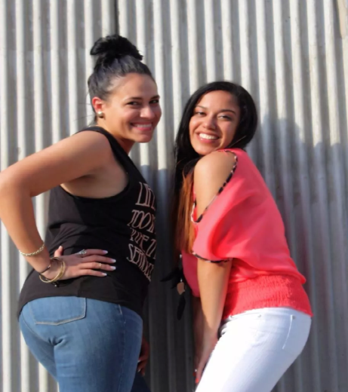
“God made us friends because no mother could handle us as sisters”
Amor: Bridesmaid + soon to be
Sissy-in-law
Cell: (917) xxx-xxxx
“I smile because your going to be my sister-in-law! I laugh because you can’t do anything about it”
Tamar : Bridesmaid + high school bestie
Cell: (347) xxx-xxxx
“True friends are those who dare to let you know your mistakes rather than agreeing with you over the wrong things.”
Marsha: Bridesmaid + comedian
Cell: xxx-xxxx
“Many people will walk in and out of your life but only true friends will leave foot prints on your heart.”
Christina: Bridesmaid + ride or die
Cell: (347) xxx-xxxx
“Best friends are like stars…you don’t always see them, but you know they are there.”
Dashima (aka Dee): Bridesmaid + my body guard
Cell: (718) xxx-xxxx
“Friendship isn’t about whom you have known the longest…it is about who came, and never left your side…”

Through this amazing journey…here’s information so that my best girls can keep in contact with each other as I start a new chapter of my life!

From the Bride…

Like you didn’t already know that you are one of my favorite people! I need you in my life…I want you by my side!

Will you be my
Bridesmaid?
This invitation is designed to make you feel part of the wedding family. Jump on in and discover my hopes and ideas for mine and Joseph’s big day!
xoxo…with love,
Amy

